K9 Addict Dog Training 2024
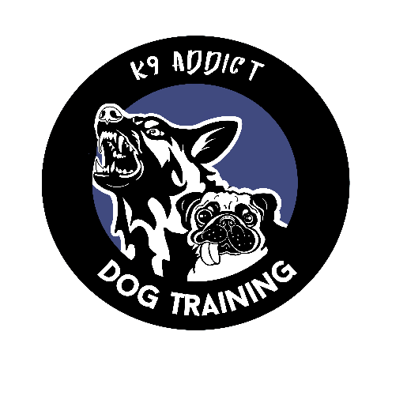
Kara Schaeffer
www.K9Addictdogtraining.com
Email: k9addictdogtraining@gmail.com
Address: 724 Welton St Harpursville NY 13787
Phone: (607)-267-2184

NAME: ________________________________________DATE: ___/___/2024

ADDRESS: ________________________________________________________

PHONE#: (___) _____-________EMAIL: _______________________________

DOG’S NAME: _____________________________BREED: ___________________

DOG’S AGE: _________ SEX: M☐ F☐

PROGRAM or CLASS: ___________________ PRICE:________________

PAID: Check _______Cash _______ Digital Payment______

In Full or Payments: _________________________________

Please make check payable to Kara Schaeffer or K9AddictDogTraining
PayPal: KaraMackenzi@hotmail.com

Private & Group lesson policy:
There are no refunds for any class or program
Paypal payments have a 3% processing fee
Lessons expire after 6 months

**READ CAREFULLY - THIS AFFECTS YOUR LEGAL RIGHTS AND OBLIGATIONS**
WAIVER, ASSUMPTION OF RISK AND AGREEMENT TO HOLD HARMLESS

I understand that my attendance at a training class is not without risk to myself, members of my family or guests who may attend, or my dog, because some of the dogs to which we will be exposed may be difficult to control and may be the cause of injury even when handled with the greatest amount of care or otherwise, and because accidents may happen in the course of moving about which may cause physical injury.

I hereby waive and release K9 Addict Dog Training , Kara Schaeffer, their landlord, employees, and agents from any and all liability of any nature, for injury or damage that I or my dog or members of my family or my guests may suffer, including specifically but not limited to any injury or damage resulting from the action or inaction of any dog or its owner or handler, or from the action or inaction of K9 Addict Dog Training , Kara Schaeffer, their landlord, or their employees or agents, whether arising from negligence or any other reason or cause whatsoever, and I expressly assume the risk of any such damage or injury while attending any training session or while on the training grounds or the surrounding area thereto.

In consideration of and as inducement to the acceptance of my application for membership in this or any K9 Addict Dog Training dog training class, I hereby agree to indemnify and hold harmless K9 Addict Dog Training, Kara Schaeffer, their landlord, or their employees and agents from any and all claims by me or claims by any member of my family or any other person accompanying me or my dog to any training session or function of K9 Addict Dog Training, or while on the grounds or the surrounding area thereto as a result of any action or inaction by any dog, including my own, or its owner or handler or from the action or inaction of K9 Addict dog Training , Kara Schaeffer, their landlord, or their employees or agents whether arising from negligence or any other reason or cause whatsoever.

I further undertake and agree to indemnify and hold harmless K9 Addict Dog Training, Kara Schaeffer, their landlord, employees and agents from all third party claims, costs, actions or causes of action which may arise at any time as a consequence of any acts or omissions of myself, my dog, my family members, or any other person accompanying me or my dog

I acknowledge that I have read and understand the terms and provisions of this WAIVER,
ASSUMPTION OF RISK AND AGREEMENT TO HOLD HARMLESS and that I am signing and delivering the same freely and voluntarily and unconditionally.

I state that my dog is up to date on all vaccinations. I know and understand that vaccinations may not always keep my dog from getting sick.

SIGNATURE OF ADULT APPLICANT: ______________________________________ DATE: _____/____/2024

